  web part 2 | Abstract  This document outlines the design and development of a web-based system focused on usability, functionality, and responsive design. The project applies key web development concepts, including front-end design, back-end processing, and database integration. Modern technologies such as HTML, CSS, and JavaScript were used to create an interactive and user-friendly interface. The system also incorporates features like dynamic content and efficient data handling. Overall, the project demonstrates the practical application of web development skills in building a functional and reliable web solution.  Group 26  WEB DEVELOPMENT

Table of Contents
Database Overview 3
Admin Structure 3
User Structure 4
Clothes Structure 5
Order Structure 6
Text Files 7
UserData.txt File 7
AdminData.txt File 8
ClothesData.txt File 9
System Features 9
GitHub Link 9

Database Overview
The system uses a MySQL database called ColthingStore. It includes tables for users, administrators, clothing items, and orders. Each table is structured with primary keys and appropriate fields to support the functionality of the web application

Admin Structure
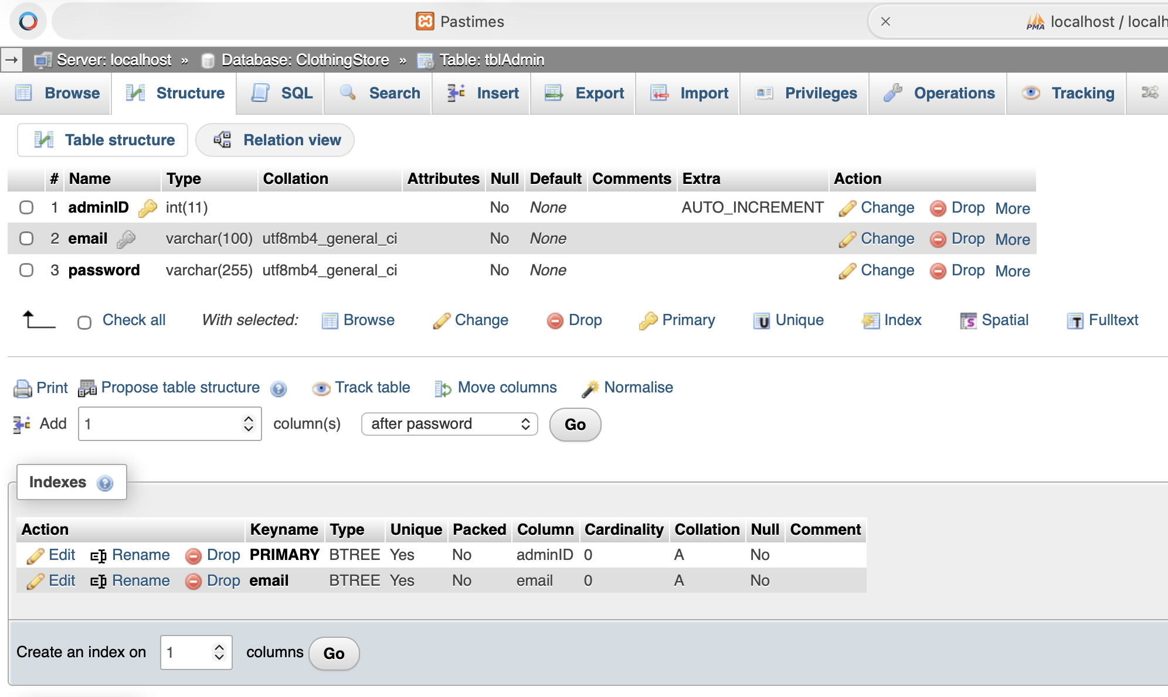
Figure 1: tblAdmin Structure

User Structure
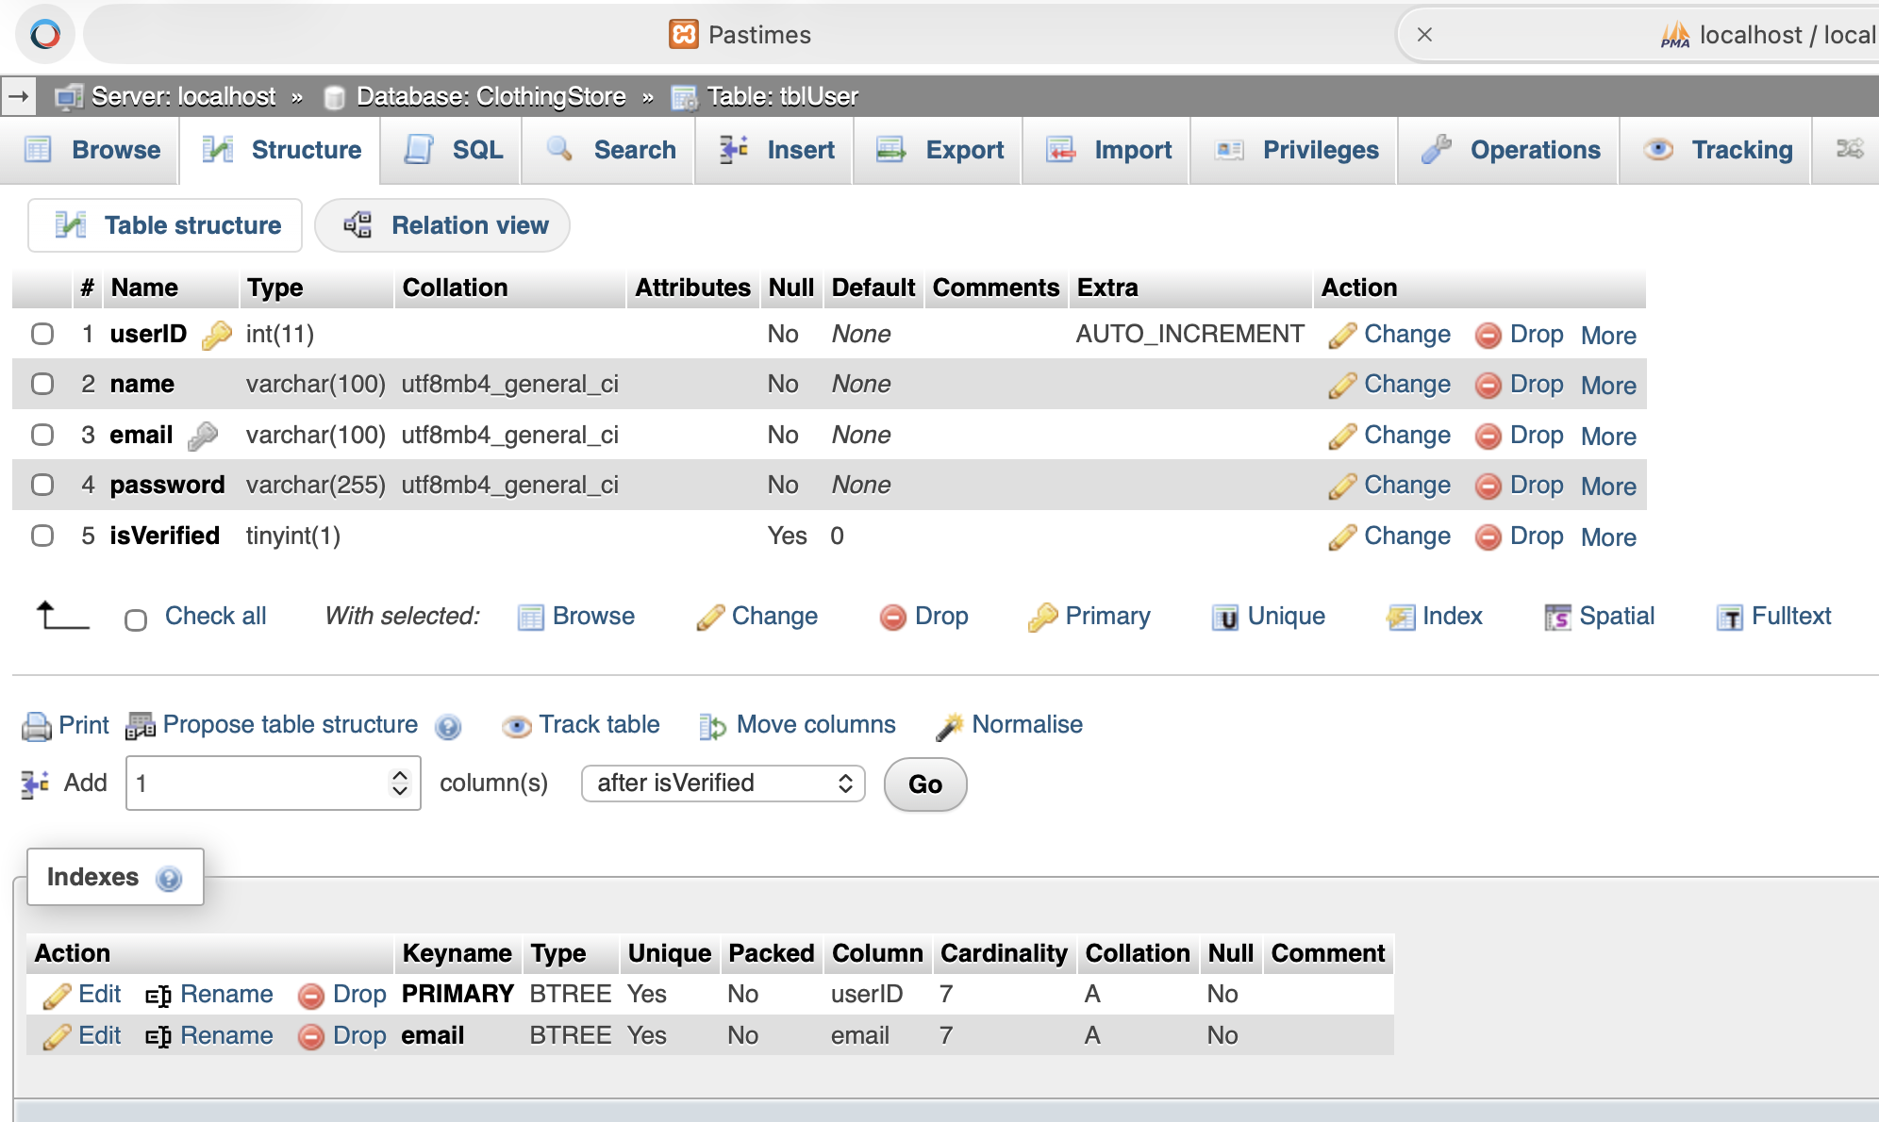
Figure 2: tblUser Structure

Clothes Structure
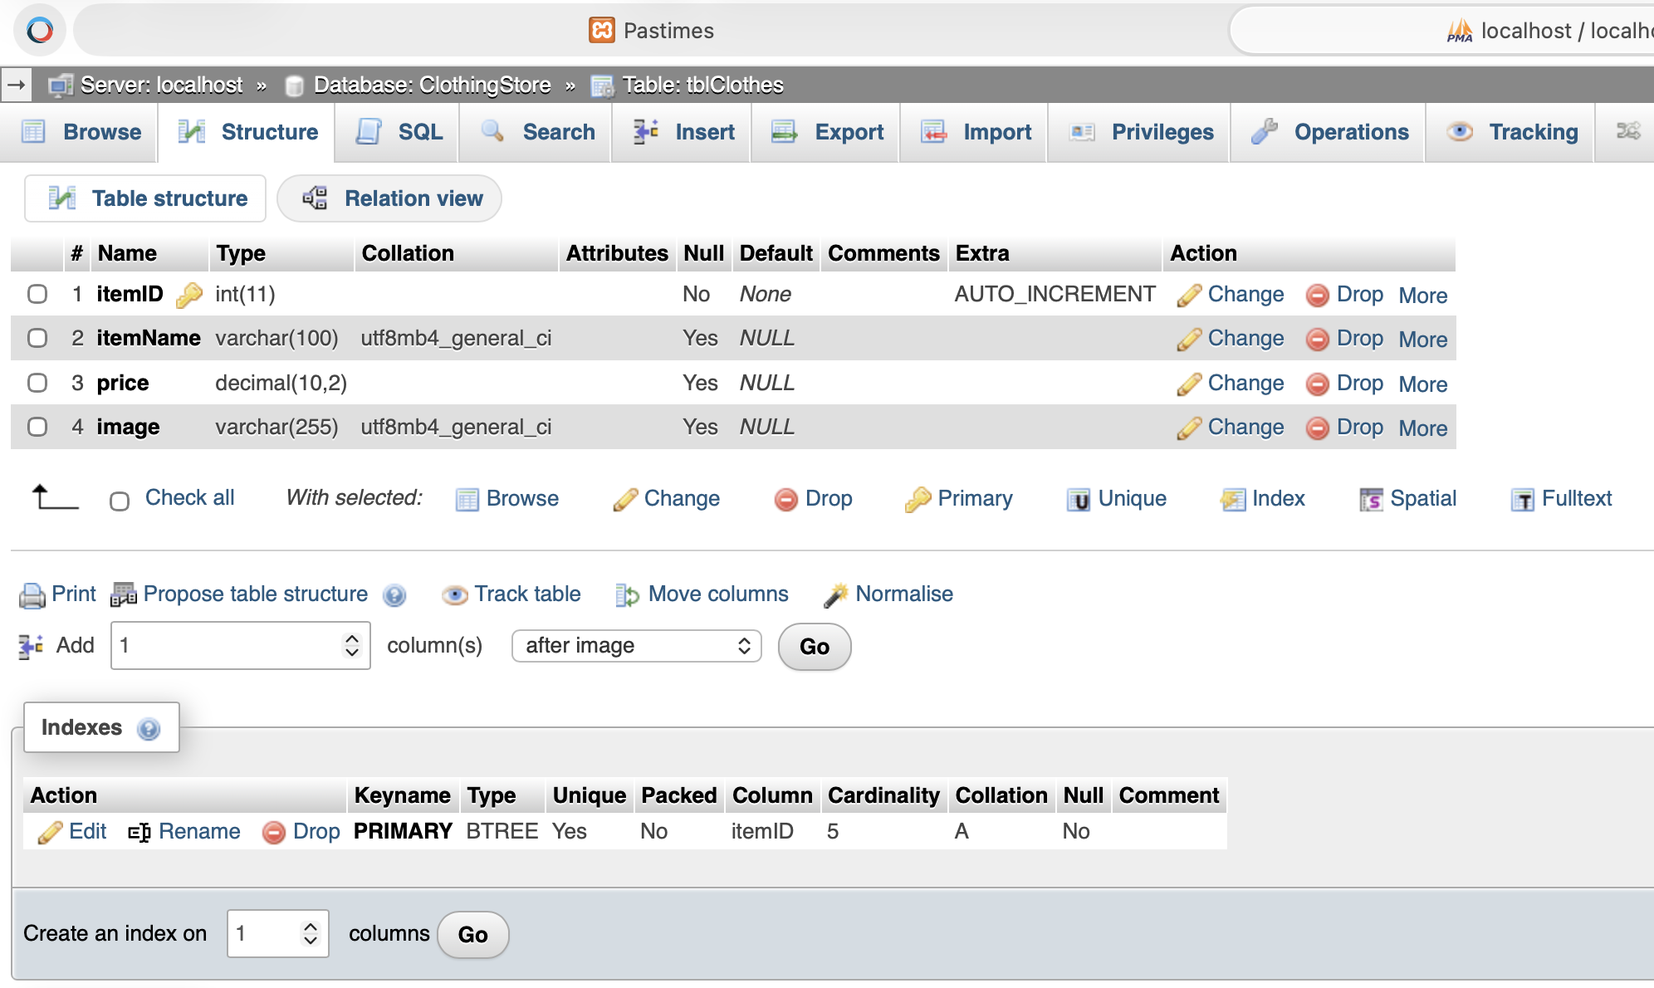
Figure 3: tblClothes Structure

Order Structure
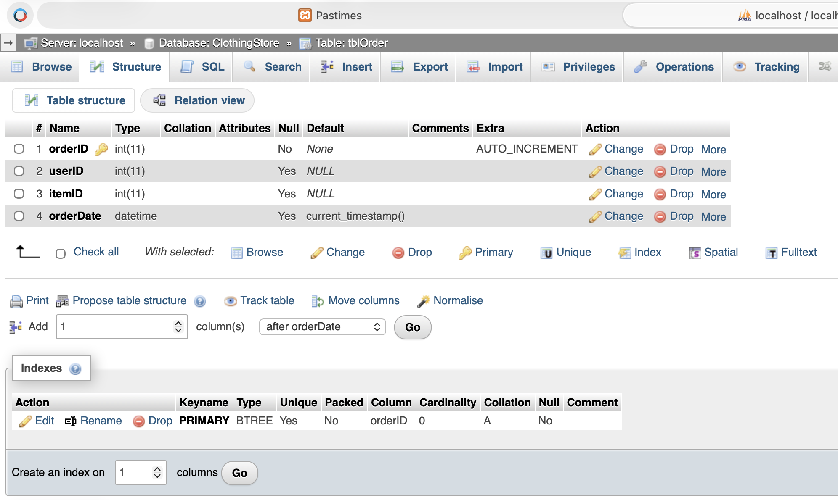
Figure 4: tblOrder Structure

Text Files

UserData.txt File
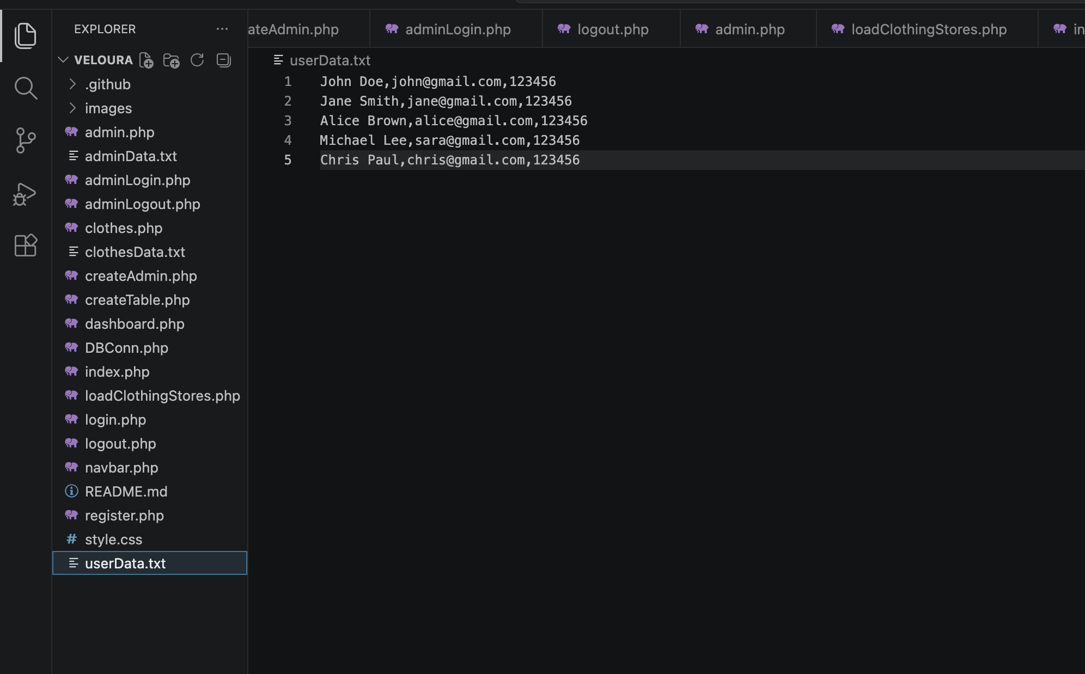
Figure 5: userData.txt

AdminData.txt File
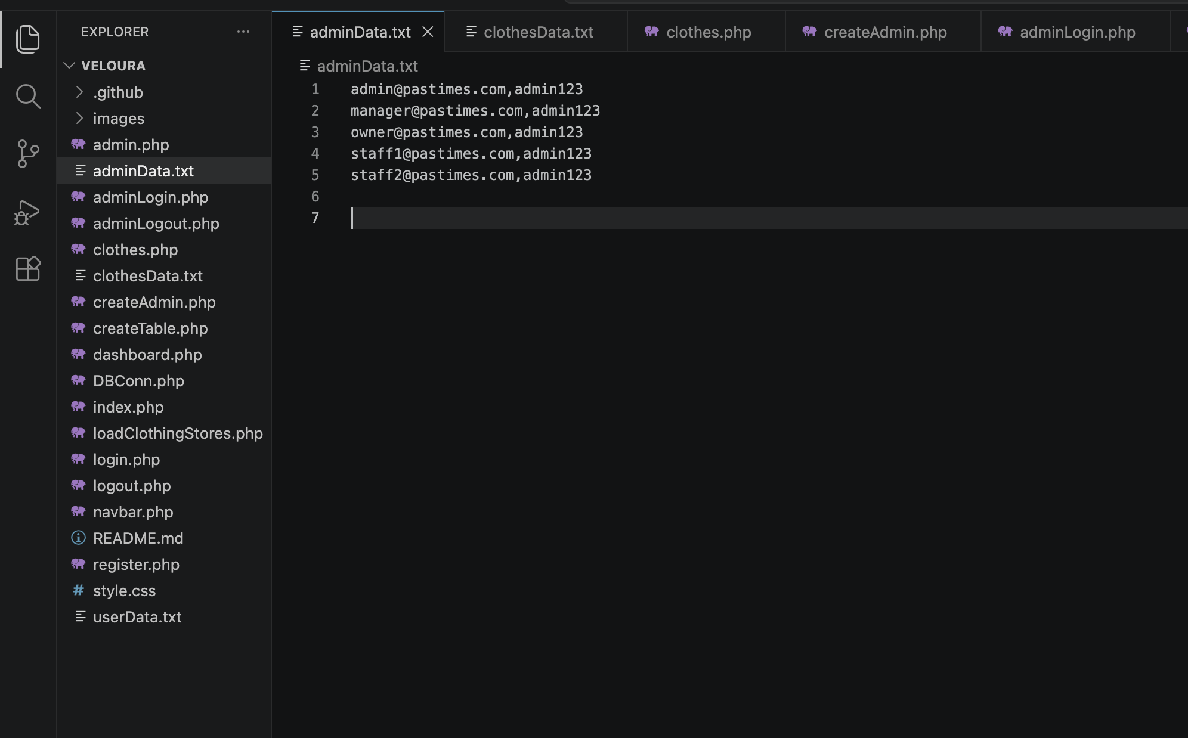
Figure 6: adminData.txt

ClothesData.txt File
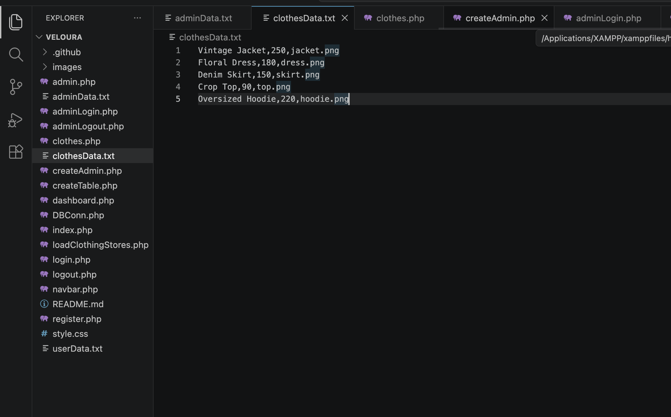
Figure 7: clothesData.txt

System Features
The system includes the following features:

- User registration with password hashing
- Admin verification of users before login
- Secure login system with session handling
- Admin dashboard for managing users (add, update, delete)
- Clothing display in a grid layout
- Add-to-cart functionality restricted to logged-in users
- Database integration using MySQL and PHP (MySQLi)

GITHUB LINK
GITHUB REPO

